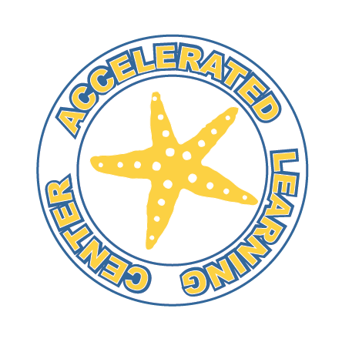
Accelerated Learning Center
4105 E Shea Blvd.
Phoenix, AZ 85028

P (602) 485-0309
F (602) 485-9356
“WE MAKE A DIFFERENCE FOR STUDENTS”
July 24, 2020
Dear ALC Parents/Guardians,
Thank you everyone who participated in our June survey. We felt it was important to consider student learning preference in creating a plan for reopening, which is detailed below.
In light of Governor Ducey’s Executive Order (2020-44) stating that Arizona public and charter schools must delay in-person learning until at least August 17, 2020, Accelerated Learning Center will begin distance learning for all students on our scheduled start date of August 12th. The ability to open our campus for on-site learning will depend on public health benchmarks that have yet to be released.
Our goal is to make on-campus learning available to our students as soon as government regulations allow, based on public health data and CDC guidelines.
ALC students have two options for this school year, Distance Learning and Phased On-Campus Learning. With either option, we will be following a modified block schedule in which students are enrolled in two classes rather than four (earning two full credits rather than four half-credits) for a trimester. This will not only alleviate the confusion of communication with multiple teachers, but it will allow us to maintain smaller class sizes and more control over social distancing.
Distance Learning students will have the opportunity to schedule individual, in-person tutoring one day per week, if needed.
Phased On-Campus Learning students will return to school as follows:
▪ Phase 1, Distance Learning: Students will work from home until government recommendations allow us to open.
▪ Phase 2, Distance Learning: Students will work from home and can schedule 1-1 in-person tutoring.
▪ Phase 3, Alternating Schedules: For example, half of the students are on campus on Monday/Wednesday, and the other half are on campus Tuesday/Thursday. This allows us to limit the number of students in a classroom to seven or fewer.
▪ Phase 4, Hybrid Learning: In-Person students will be assigned a project to work on independently every Wednesday so that teachers are available for Distance-Learners wanting 1-1 tutoring. Distance-Learners can schedule 1-1 tutoring every Wednesday with their teachers to ensure that they are getting the help and support that they need and to provide them an environment in which they feel safe.
As mentioned in the previous letter from June 29th, rest assured that we are taking various health and safety precautions to protect everyone on campus. This means all students and staff will be required to wear face coverings, although there will be opportunities for students to safely remove them at scheduled times.
As we get closer to our August 12th start date, keep an eye out for
further details regarding student schedules, technology equipment loans, and procedures for accessing online learning.
As always, thank you for your continued support and patience during these unprecedented times.
Sincerely,
Mrs. Curran

